

VIETNAM – KOREA UNIVERSITY OF INFORMATION AND COMMUNICATION TECHNOLOGY

DEPARTMENT OF COMPUTER & ELECTRONIC ENGINEERING

CLOUD COMPUTING

Research on Resource Provisioning Model in Cloud Computing: Building a Shared Virtual Server with Microsoft Azure.

Students: DOAN HUNG QUAN
TRAN DINH TRUONG HAI DOAN DUC GIA HUY

Class: 21SE
Instructor: DR.DANG QUANG HIEN
Da Nang, May 2025

VIETNAM – KOREA UNIVERSITY OF INFORMATION AND COMMUNICATION TECHNOLOGY

DEPARTMENT OF COMPUTER & ELECTRONIC ENGINEERING

CLOUD COMPUTING

Research on Resource Provisioning Model in Cloud Computing: Building a Shared Virtual Server with Microsoft Azure.

Students: DOAN HUNG QUAN
TRAN DINH TRUONG HAI DOAN DUC GIA HUY

Class: 21SE
Instructor: DR.DANG QUANG HIEN

INSTRUCTOR’S COMMENTS

…………………………………………………………………………
…………………………………………………………………………
…………………………………………………………………………
…………………………………………………………………………
…………………………………………………………………………
…………………………………………………………………………
…………………………………………………………………………
…………………………………………………………………………
…………………………………………………………………………
…………………………………………………………………………
…………………………………………………………………………
…………………………………………………………………………
…………………………………………………………………………
…………………………………………………………………………
…………………………………………………………………………

Instructor’s signature,

Dr. Dang Quang Hien

ACKNOWLEDGEMENTS
We would like to express our profound gratitude to Dr.Dang Quang Hien and esteemed faculty members of the University of Information Technology and Communication Viet-Han for their dedicated guidance and support throughout our study at the university, especially during the research and completion of this report.
During the report preparation process, due to limited practical experience, there may still be some shortcomings in our report. We sincerely hope to receive feedback, evaluation, and suggestions from you.
Once again, we sincerely thank all of you, and we wish you continued success in both life and work.

ABSTRACT
Cloud computing is a technology that is increasingly developing and becoming popular in various industries and enterprises. It is a form of storing and processing data on remote servers, rather than storing and processing it on individual computers or servers within a business.
With the development of cloud computing, users can easily access applications and data from anywhere in the world, as long as they have an internet connection. This makes working and collaborating easier, while also reducing costs and optimizing resources within the enterprise.
Cloud computing can also increase the flexibility and reliability of information systems, helping businesses to easily expand and upgrade their systems without worrying about managing hardware or installing new software.
However, with these benefits comes the need to enhance security to protect users' information on cloud platforms. Therefore, the development of cloud computing also requires cloud service providers to ensure security and comply with information security regulations.

TABLE OF CONTENTS
LIST OF FIGURES vi
INTRODUCTION 1
CHAPTER 1: OVERVIEW OF CLOUD COMPUTING 1
  - What is Cloud Computing? 1
  - Essential Characteristics of Cloud Computing 1
  - Classification of Cloud Computing models 2
    - Public Cloud 2
    - Private Cloud 3
    - Hybrid Cloud 4
    - Community Cloud 5
  - Types of Cloud Computing Services 5
    - Infrastructure as a Service (IaaS) 5
    - Platform as a Service (PaaS) 6
    - Software as a Service (SaaS) 6
  - Operating mechanism of Cloud Computing 6
CHAPTER 2: INTRODUCTION TO MICROSOFT AZURE 8
  - Microsoft Azure Overview 8
  - Architecture and operating principle 8
    - Microsoft Azure Overview Architecture 8
    - Cost and Capacity Optimization 9
  - Benefits and practical applications of Microsoft Azure 9
  - Chapter Summary 10
CHAPTER 3. HOST A WEBSITE ON LINUX SERVER IN AZURE 11
  - Virtual machine setup 11
  - How to deploy website in ubuntu 14
CHAPTER 4: DEMO DEPLOY TO WEB APP VIA MS AZURE 18
  - Web App setup 18
  - CI/CD Setup 21
CONCLUSION x
REFERENCES LIST xi

LIST OF FIGURES
Figure 1. 1 Cloud Computing models 2
Figure 1. 2 Types of Cloud Computing Services 5
Figure 1. 3 Operating mechanism of Cloud Computing 6
Figure 1. 1 Cloud Computing models 2
Figure 1. 2 Types of Cloud Computing Services 5
Figure 1. 3 Operating mechanism of Cloud Computing 6
Figure 3.1 Home page Azure Portal 11
Figure 3.2 Create Virtual machine 11
Figure 3.3 Fill information VM 12
Figure 3.4 Setup OS, size virtual machine 12
Figure 3.5 Setup authentication, ports 13
Figure 3.6 Review virtual machine 13
Figure 3.7 Access to virtual machine 15
Figure 3.8 Login to VM 15
Figure 3.9 Install Apache Server 16
Figure 3.10 Upload sourcecode into apache 16

vi

GLOSSARY

 | ACRONYMS | DECREPSTION
1 | VM | Virtual Machine
2 | MS | Microsoft
3 | IaaS | Infrastructure as a Service
4 | PaaS | Platform as a Service
5 | SaaS | Software as a Service

INTRODUCTION

CHAPTER 1: OVERVIEW OF CLOUD COMPUTING

What is Cloud Computing?
Cloud computing is a technology model that allows accessing and sharing services and computing resources over the internet. Instead of having to own and manage their own servers and IT infrastructure, organizations can use virtual servers and store data in remote data centers managed by service providers cloud. This helps reduce costs, increase flexibility, and ensure easy scalability for businesses.
Cloud computing has become an important part of most business and information technology fields, providing a foundation for application development, data storage, and deployment of online services.

Essential Characteristics of Cloud Computing

On-demand self-service:
Before the cloud, an individual or business would need to buy, configure, and install an IT infrastructure to support their computing needs. With the advent of AWS, Microsoft Azure, Google Cloud, and other public cloud platforms, it is now possible to access the IT tools you need much more quickly. You also don’t need to provision the servers, databases, or other computing capabilities yourself, and you can get started without understanding the underlying technology.

Broad network access:
Gone are the days when an individual needed to be onsite, in front of a desktop connected by a cable to the server, an internet connection, and other technology. The cloud provides broad network access, with resources available from anywhere with an internet connection.

Elastic resource pooling:
Elastic Algorithm Service (EAS) of Platform for AI (PAI) provides the elastic resource pool feature. This feature allows you to scale out a service that is deployed in a dedicated resource group even if the node resources of the resource group are insufficient.

Rapid elasticity:
The ability of a cloud system to quickly scale up or down in response to changes in demand or usage. It is used in cloud computing to ensure that a system has the necessary
resources to handle sudden increases in traffic or workload without affecting performance or availability.

Measured Service:
Measured Service in Cloud Computing refers to the ability to monitor and control computing resources usage. It involves continuously tracking the consumed resources, such as storage, processing power, and network bandwidth, which enables transparency for both the provider and users. This dynamic approach leads to more efficient use of resources and allows for users to pay only for the services they actually consume.

Classification of Cloud Computing models

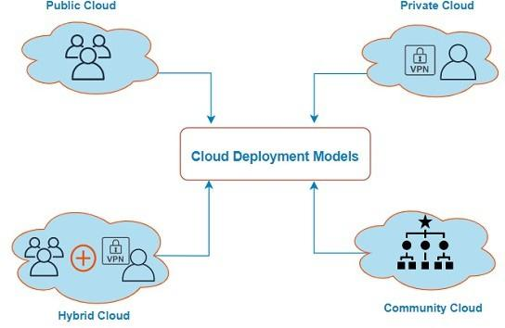

Figure 1. 1 Cloud Computing models

Public Cloud
Public Cloud is a public cloud model where computing resources are shared and managed by a cloud service provider. Many individuals, organizations and businesses have the right to access and use via the internet. This is suitable for organizations and individuals who need flexibility and cost savings, as they only pay for the resources they use.

How does public cloud work?
A public cloud works by using a shared pool of computing resources—such as servers, storage, and networking—provided by a third-party cloud service provider over the internet. These resources are hosted in the provider’s data centers and made available to multiple customers on a pay-as-you-go or subscription basis.

Advantages:
      - Cost efficiency
      - Scalability and flexibility
      - Accessibility and mobility
      - Security and compliance
      - Access to cutting-edge technologies

Disadvantages:
- Security issues need to be paid more attention due to common use.

- Performance may be affected by other users' activities.

Private Cloud
A private cloud is a dedicated cloud computing environment used by a single organization. Unlike public clouds, which share resources across multiple users, a private cloud offers exclusive access to computing power, storage, and networking. This approach gives businesses greater control, enhanced security, and the ability to customize their infrastructure to meet specific needs. Private cloud technology can be hosted on-premises or by a third-party provider, offering flexibility while maintaining privacy and compliance.

How does the private cloud work?
A private cloud gives a single organization exclusive access to computing resources, whether hosted on-premises or by a third-party provider. Unlike public clouds, where resources are shared, a private cloud runs on dedicated infrastructure—offering more control, security, and customization.
Virtualization plays a key role, allowing businesses to run multiple applications on the same hardware while keeping workloads separate. Automation helps manage resources efficiently, so teams can scale up or down as needed. With built-in monitoring and security tools, a private cloud makes it easier to meet performance and compliance needs while staying flexible.

Advantages:
- Stronger security and compliance.

- More flexibility and customization.

- Better performance and reliability.

- Scalability without waste.

- Hosting that fits your needs.

Disadvantages:
- Management is more complicated due to having to work with two environments.

- Requires good integration between systems.

Hybrid Cloud
Hybrid clouds combine public and private clouds, bound together by technology that allows data and applications to be shared between them. By allowing data and applications to move between private and public clouds, a hybrid cloud gives your business greater flexibility and more deployment options and helps optimize your existing infrastructure, security, and compliance.

How does the hybrid cloud work?
Hybrid cloud computing combines public and private cloud environments, allowing applications, services, and workloads to be shared between them. By adopting the hybrid model, organizations can choose where to run their workloads based on their business needs, resulting in greater flexibility, scalability, and cost efficiency—all while retaining control over specific resources.
With the hybrid cloud, organizations can experience the best of both worlds. They can rely on the third-party public cloud to scale and optimize their resources while still using the on-premises, private cloud to manage more critical workloads that may require greater levels of security or control.
Hybrid cloud environments are typically managed through a centralized cloud management platform, which gives users full visibility over their entire infrastructure. Cloud management solutions also allow for the seamless integration, orchestration, and management of resources between the two environments, often using APIs and orchestration tools.

Advantages:
- Flexibility in combining public and private resources.

- Scalability

- Business continuity

- Improved performance

- Security and compliance

- Innovation and agility
- Provides comprehensiveness and cost effectiveness.

- Meets the special needs of each application.

Disadvantages:
- Management is more complicated due to having to work with two environments.

- Requires good integration between systems.

Community Cloud
Community Cloud is a cloud model shared among a group of organizations or businesses with common goals or regulations. It provides greater privacy and control than Public Cloud, but still allows resource sharing among community members. Community Cloud is often used in industries with strict regulations or special needs such as healthcare or education.
Advantages:
- Resource sharing and management within a specific community.

- Meet the unique needs of an industry or community.

- Security is centralized and tightly managed.
Disadvantages:
- It is necessary to have a common community or industry to make sense.

- Scalability may be limited if there is not great demand.

Types of Cloud Computing Services
Cloud Computing offers a diverse range of services to meet the needs of users and organizations. These services are often classified into three main categories: Infrastructure as a Service (IaaS), Platform as a Service (PaaS), and Software as a Service (SaaS). Each of these service types has different levels of control and management, suitable for specific goals and applications.
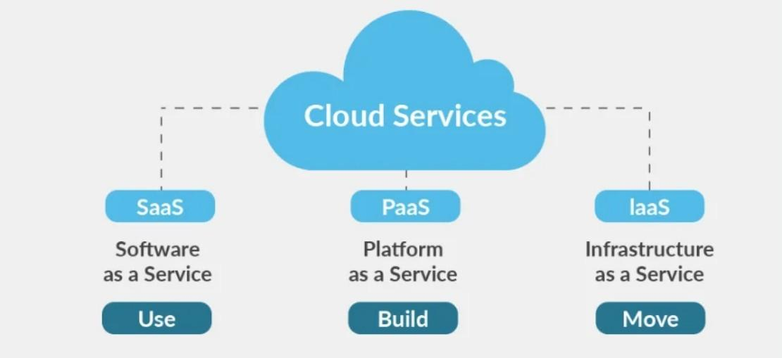
Figure 1. 2 Types of Cloud Computing Services

Infrastructure as a Service (IaaS)
Infrastructure as a Service (IaaS) provides basic computing resources such as virtual servers, storage, and networking through the cloud. IaaS allows users to rent and manage these resources without worrying about hardware administration. This is suitable for those who want greater control over their systems and applications, from configuration to operating system.

Platform as a Service (PaaS)
Platform as a Service (PaaS) provides an application development environment and services, including tools and frameworks. PaaS makes application development quick and easy, eliminating the need to manage infrastructure. Users only need to focus on coding and deploying the application, and the rest is managed by the cloud provider.

Software as a Service (SaaS)
Software as a Service (SaaS) provides applications and software through the cloud. Users can access and use these applications over the internet without having to install and manage them on personal computers. SaaS typically includes applications such as email, financial management, HRM, CRM, and many others.

Operating mechanism of Cloud Computing
Cloud computing operates through a model of distributing services and computing resources over the internet.
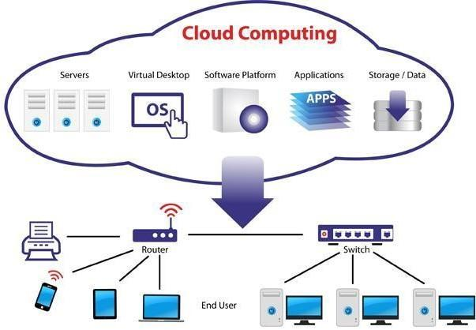

Figure 1. 3 Operating mechanism of Cloud Computing

Here's how cloud computing basically works:
- Cloud infrastructure: Cloud service providers (Example: Amazon Web Services,
Microsoft Azure, Google Cloud) build and maintain powerful data centers containing thousands of servers and network infrastructure advanced.
- Virtualization: Computing resources such as servers and storage are virtualized. This
allows multiple virtual servers to run on the same physical server and resources to be divided flexibly.
- Configuration: Users sign up for specific services (e.g., virtual servers, storage, databases) and configure them based on their needs through the cloud administration interface.
- Internet access: Users access resources and services using internet-connected devices and necessary applications.
- Usage-based billing: Instead of having to procure and maintain infrastructure, users pay
only for the resources and services they actually use. Usually on a monthly or annual payment model.
- Management and maintenance: Cloud service providers are responsible for managing
and maintaining the infrastructure, ensuring that resources are always available and functioning well.
- Scalability and flexibility: Users have the ability to quickly scale up or down resources as needed, helping them respond to business changes and challenges.
This mechanism helps optimize resources, reduce costs, increase flexibility and ensure the availability of services and computing resources.

CHAPTER 2: INTRODUCTION TO MICROSOFT AZURE

Microsoft Azure Overview
Cloud computing platforms are growing rapidly and playing an important role in IT infrastructure. The two platforms that dominate the market are Amazon Web Services and Microsoft Azure. Although not as widely available as Amazon’s platform, Azure is still highly regarded for its incredible growth rate.
Microsoft Azure is a public cloud computing platform developed by Microsoft with solutions including Infrastructure as a Service (IaaS), Platform as a Service (PaaS), and Software as a Service (SaaS). It provides hundreds of computing, storage, data analytics, artificial intelligence, security, and more services and enables businesses and developers to build, deploy, and manage applications through Microsoft's global datacenter system.
Launched in 2010 as Windows Azure, it focused on providing cloud infrastructure (IaaS) and application development platform (PaaS) for businesses. In 2014, Azure officially changed its name to Microsoft Azure to better reflect its ability to support multiple operating systems and programming languages, not just Windows. And to date, Azure is one of the world's leading cloud computing platforms, providing more than 200 services including AI, Big Data, IoT, security, data analytics and DevOps.
Azure is a cloud platform that is very fast, highly flexible and affordable. That makes it one of the best public cloud services on the market and one of the three largest cloud platforms in the world, alongside Amazon Web Services (AWS) and Google Cloud Platform (GCP).

Architecture and operating principle

Microsoft Azure Overview Architecture
Microsoft Azure is built on a globally distributed architecture that ensures high availability, reliability, and scalability for cloud computing services. The Azure system consists of three main components: Data Centers, Regions and Availability Zones, and the Azure Fabric Controller.
Data Centers: Microsoft operates hundreds of data centers spread across more than 60 global geographic regions. These data centers are connected by high-speed network infrastructure, supporting a range of cloud-based computing, storage, and networking services.
Regions and Availability Zones:
      - A region is a defined geographic area that contains one or more data centers.
      - Availability Zones are independent data centers within the same Region, designed to ensure that services remain stable even if a failure occurs in one of the data centers.
Azure Fabric Controller: This is the core component of the Azure system, which manages, monitors, and coordinates hardware resources, virtual machines, and applications across the entire platform. Fabric Controller automatically handles the deployment, restart, and redistribution of resources to optimize performance and reliability.

Cost and Capacity Optimization
Azure operates on the core principles of modern cloud computing platform design:
Virtualization: Hardware resources are virtualized into independent virtual machines so that users can deploy applications and services without having to worry about physical infrastructure. This helps optimize costs and increase operational flexibility.
Multi-tenancy architecture: Azure supports multiple users sharing hardware infrastructure while still ensuring security and performance for each account through a resource separation mechanism.
Scalability & Elasticity: The system allows increasing or decreasing the number of resources such as virtual machines, containers, and services according to actual needs, thereby optimizing costs and quickly responding to load changes.
Load Balancing: Azure integrates load balancing services to distribute traffic across multiple servers, helping to maintain consistent performance and avoid overloading a single point.
Resource Management: Users can manage, deploy, and monitor resources through tools such as the Azure Portal, Azure CLI, PowerShell, and Azure Resource Manager (ARM). ARM supports the Infrastructure as Code model, which helps automate deployment processes and minimize manual errors.

Benefits and practical applications of Microsoft Azure
Microsoft Azure is a comprehensive cloud computing platform that brings many practical benefits to businesses in the digital transformation process. First of all, Azure provides flexible scalability, allowing users to easily increase or decrease resources according to actual usage needs, thereby optimizing operating costs. In addition, Azure is tightly integrated with products in the Microsoft ecosystem such as Office 365, Windows Server and Active Directory, making it easy for businesses to deploy and manage the system.
This platform also strongly supports modern software development models such as DevOps and CI/CD through tools such as Azure DevOps and GitHub Actions. In terms of security, Azure meets more than 90 global standards and certifications, and provides a real­time security monitoring system, helping to effectively protect user data.
Azure is widely used in many fields. For example, Coca-Cola uses Azure to manage smart supply chains; BMW applies this platform in Industry 4.0 manufacturing; eBay uses Azure to process big data and improve user experience. In addition, many universities and financial institutions are also using Azure to deploy online learning, data analysis and ensure information security.
Thus, Microsoft Azure not only brings technological efficiency but also contributes to improving competitiveness and promoting innovation in modern enterprises.

Chapter Summary
This chapter has presented a comprehensive overview of Microsoft Azure - one of the world's leading cloud computing platforms today. With a strong development history since 2010, Azure has continuously expanded its scale and improved its services to meet the increasing needs of businesses in the digital age.
Azure's architecture is built on a global data center system, geographic regions and availability zones, combined with the Fabric Controller, ensuring high availability, reliability and flexible scalability. In terms of operating principles, Azure follows modern cloud computing design standards such as virtualization, multi-tenancy, flexible scalability and load balancing, helping to optimize costs and operational performance.
In addition, Azure brings many practical benefits to businesses, from easy integration with the Microsoft ecosystem, DevOps support, to strong security and compliance with global standards. The platform has also been successfully applied in various fields such as manufacturing, finance, e-commerce and education, affirming the important role of Azure in promoting digital transformation and innovation.
Overall, Microsoft Azure is not only an advanced technology solution but also a strategic platform that helps organizations enhance their competitiveness, develop sustainably and adapt effectively to the rapidly changing technology landscape.

CHAPTER 3. HOST A WEBSITE ON LINUX SERVER IN AZURE

Virtual machine setup
Step 1: Create virtual machine
After logging into MS Azure. Select Virtual Machine option.
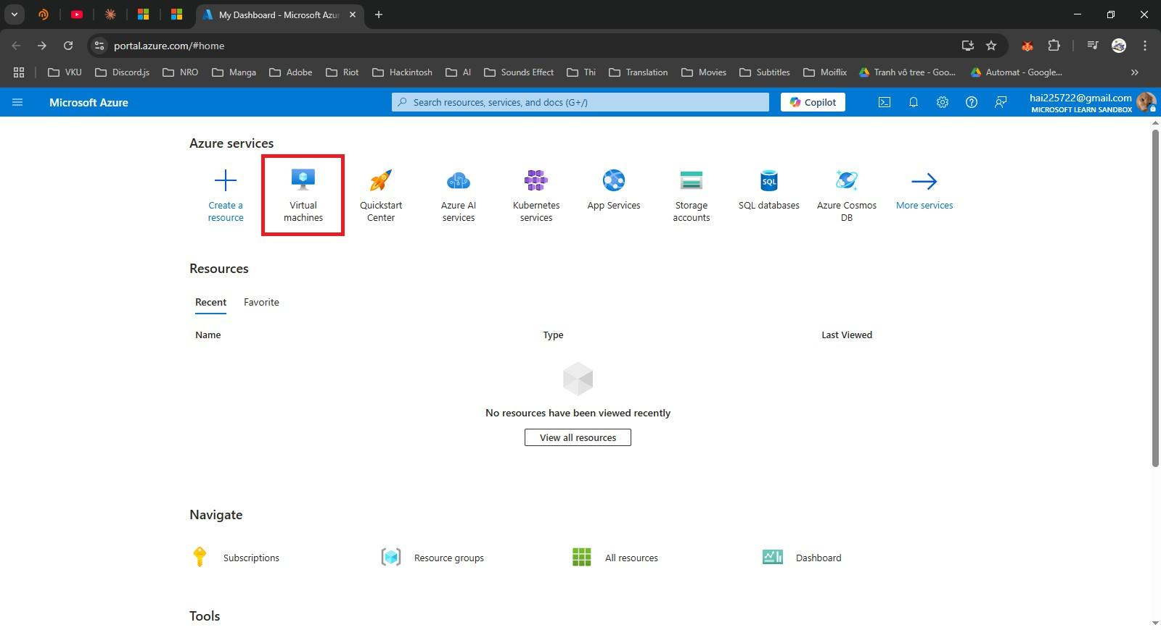
Figure 3.1 Home page Azure Portal

Then select Azure virtual machine
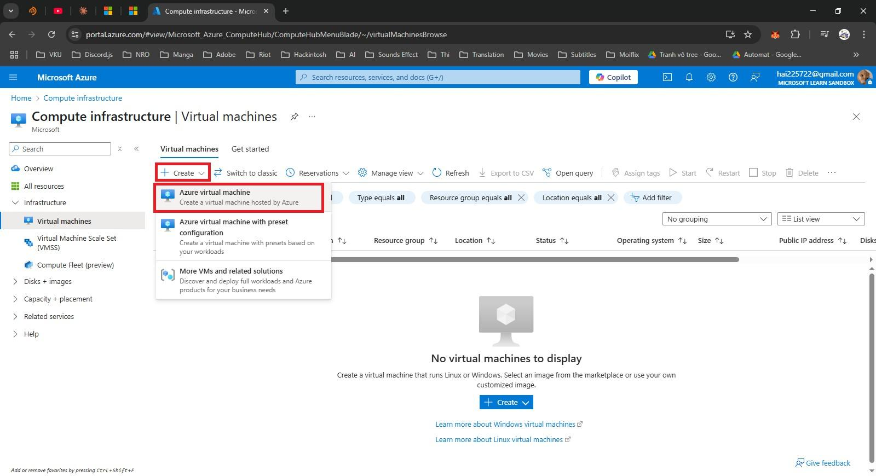
Figure 3.2 Create Virtual machine

Step 2: Fill in the necessary information (virtual machine name, technical specifications…)
Fill in the server name and select the area, the closer the faster the access speed
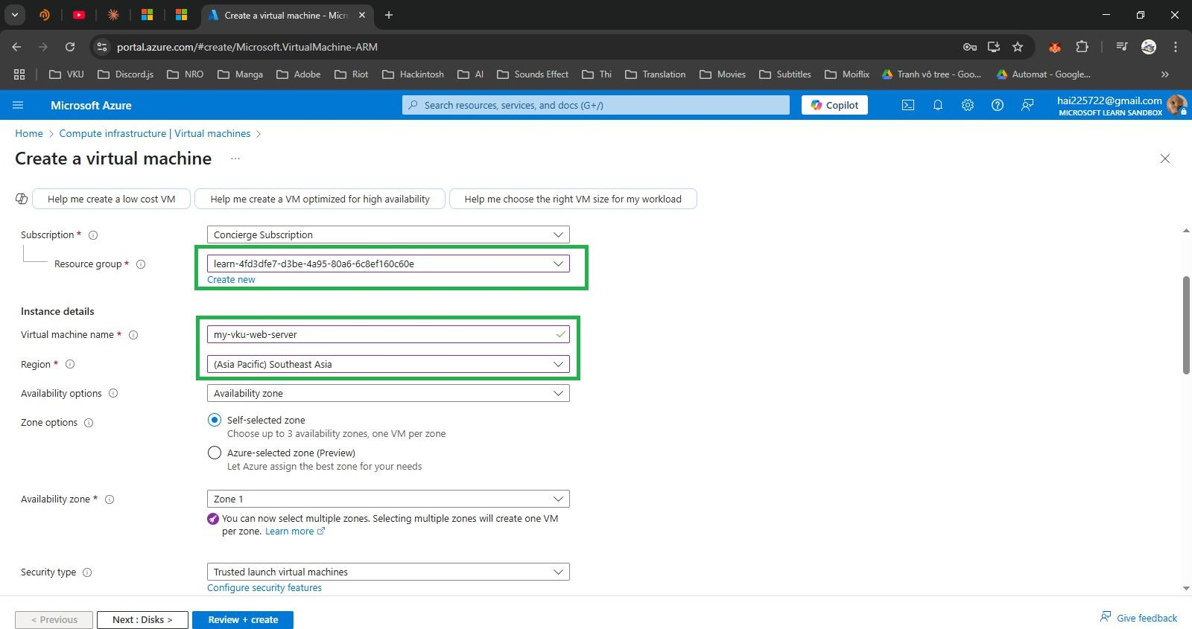

Figure 3.3 Fill information VM

Next we choose the operating system and size.
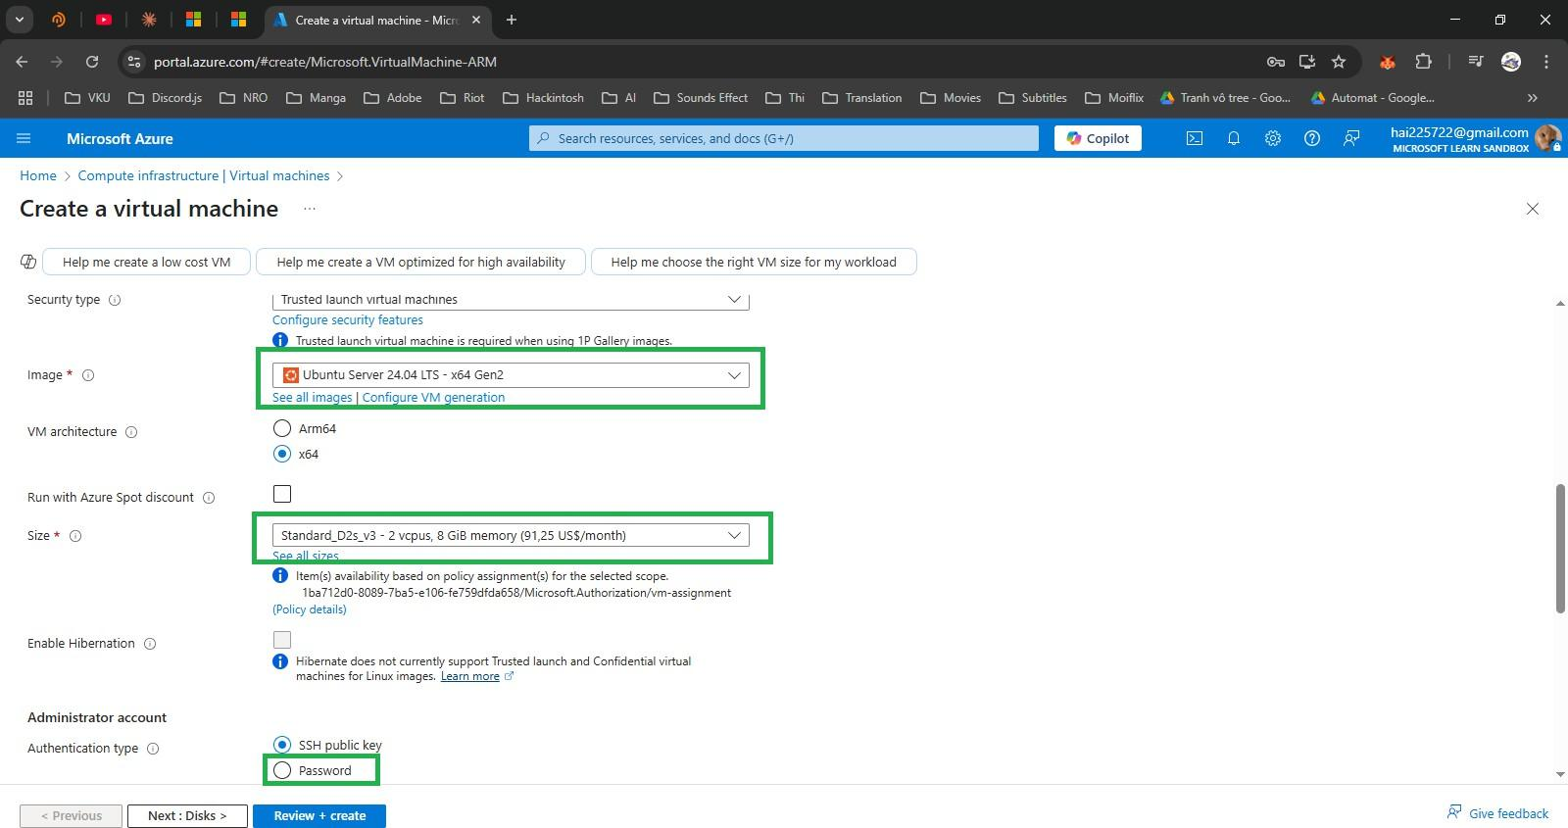

Figure 3.4 Setup OS, size virtual machine
In the authentication type section, select password, set username and password. Then select. the ports.
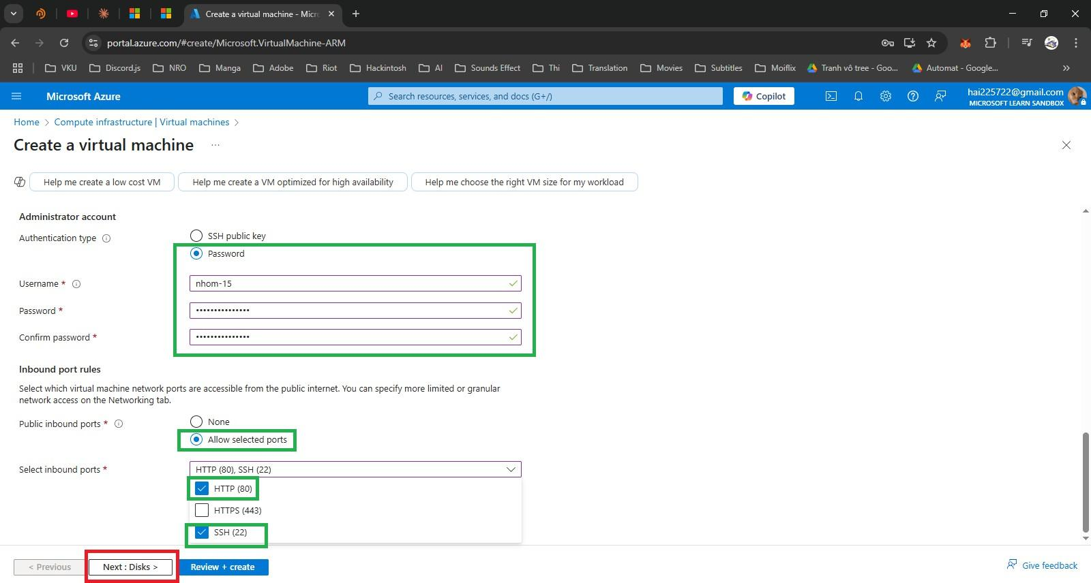
Figure 3.5 Setup authentication, ports

The parameters of Disk, Networking, Management, Monitoring, Advanced, Tags leave the default values.
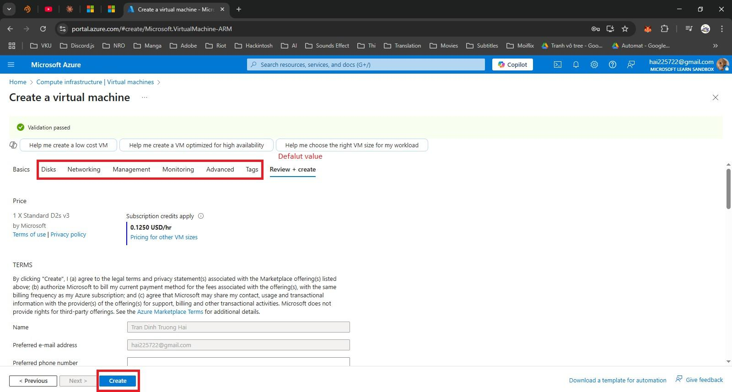
Figure 3.6 Review virtual machine

Step 3: Here we will review the settings and see the cost of creating a virtual machine. Then click Create. After the virtual machine deployment is successful, Select Go to resource.
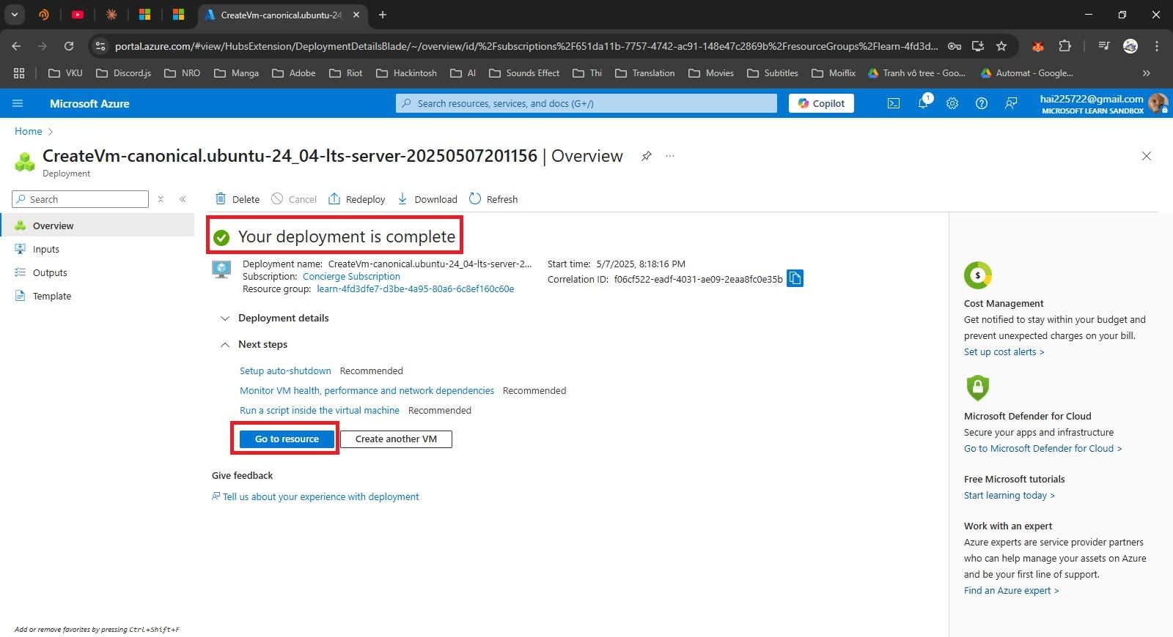
All parameters of the virtual machine after deployment. Pay attention to the server's IP address, we will use it to access the server.
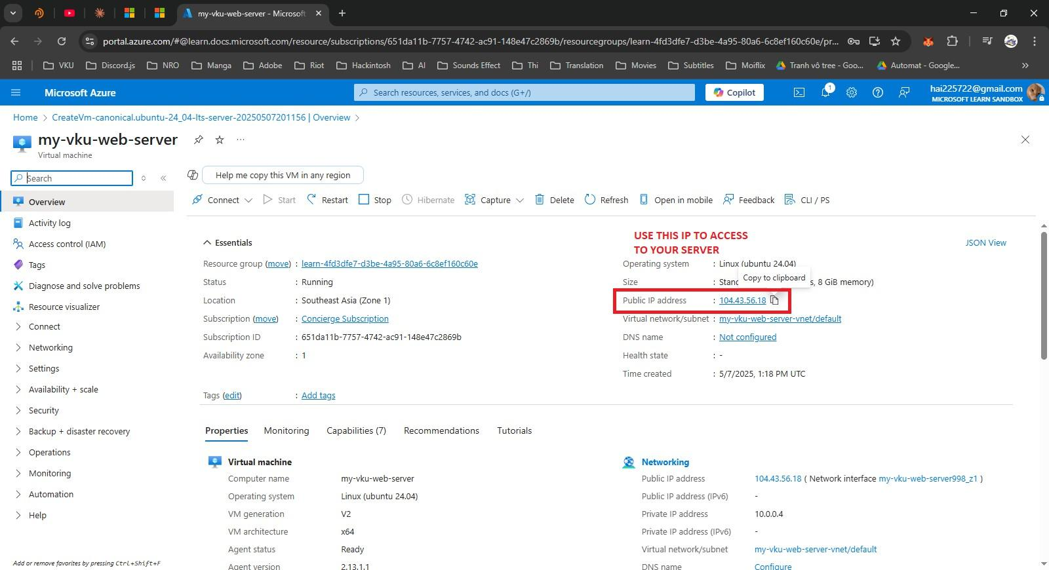

How to deploy website in ubuntu
Step 1: Proceed to access the server with the previous virtual machine IP
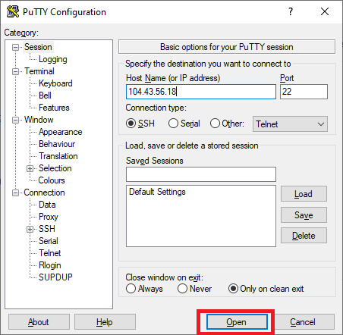
Figure 3.7 Access to virtual machine

Step 2: Log in with the previously created administrator account (nhom-15)
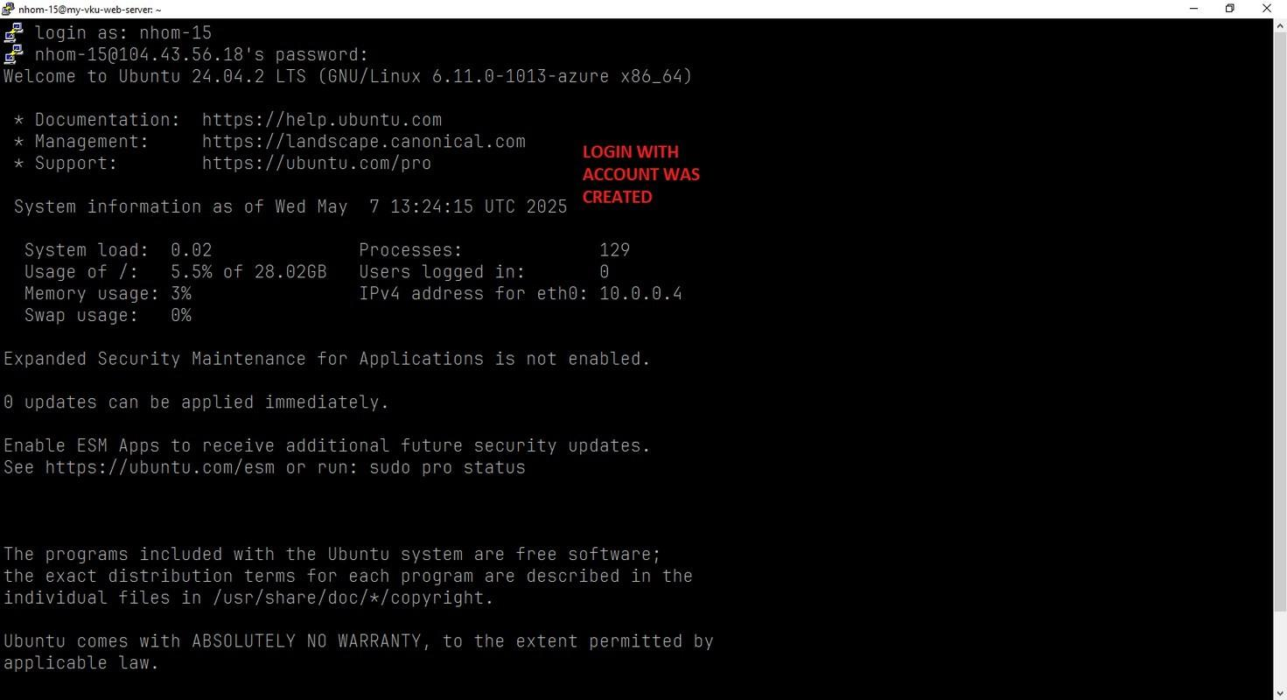
Figure 3.8 Login to VM

Next, Install Apache Server.
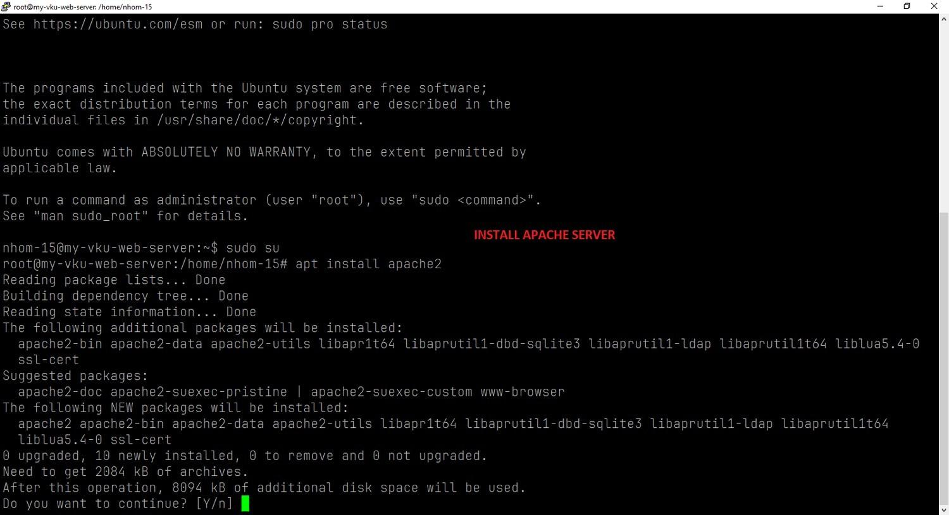

Figure 3.9 Install Apache Server

Clone the project code from GitHub and put the project into the Apache directory:
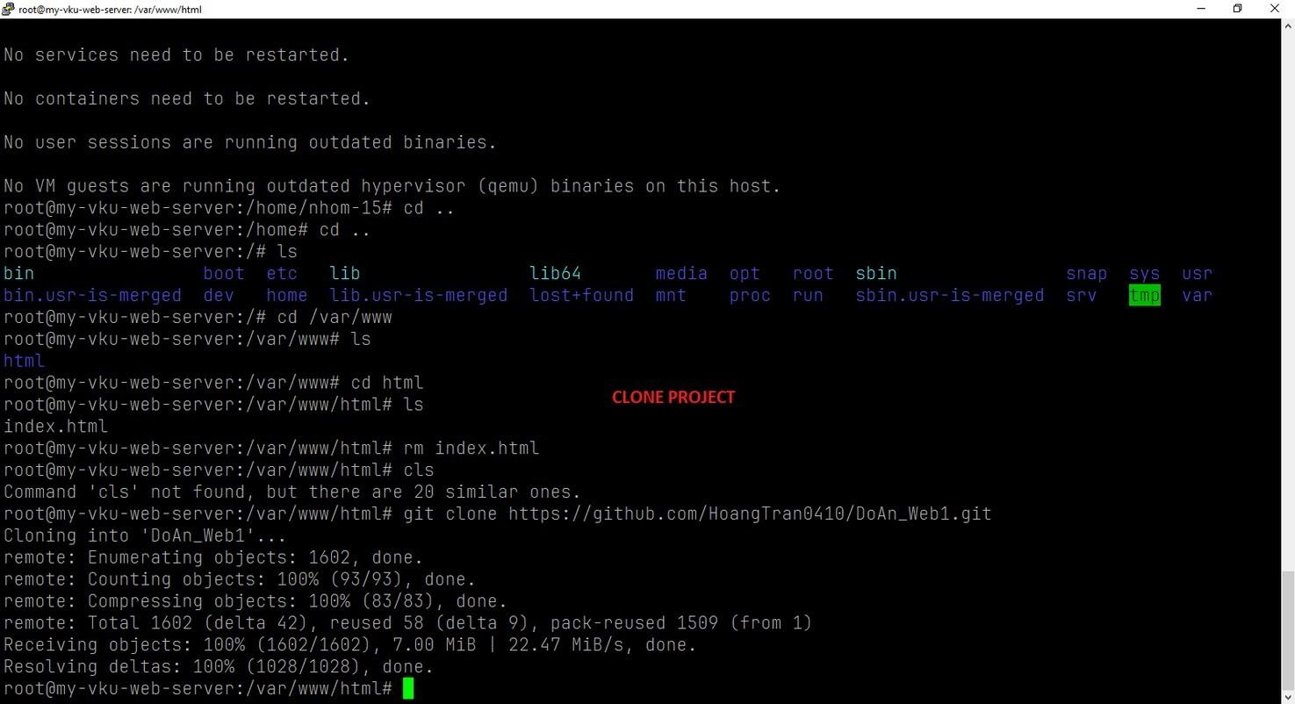

Figure 3.10 Upload sourcecode into apache
Access the IP address and see the results: 104.43.56.18/DoAn_Web1

So we have successfully hosted a website on Linux server in Azure.

CHAPTER 4: DEMO DEPLOY TO WEB APP VIA MS AZURE

Web App setup
First, we create a new Resource Group. The purpose of this is to group various tasks (such as virtual machines, databases, networks, and storage) into a logical unit for easier management. It is advisable to choose a region close to users or applications to optimize access speed
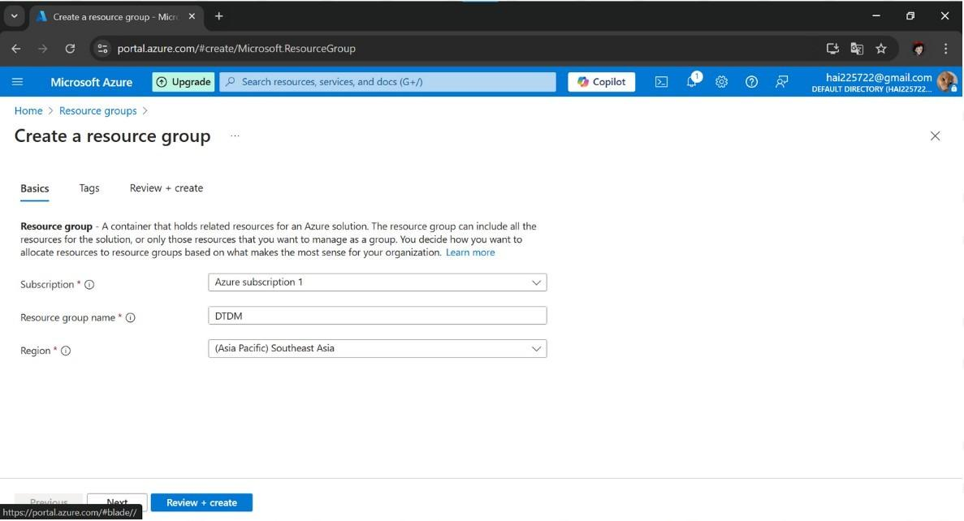
The next step is to create an SQL Database Server. We select SQL Servers, choose the RG we created, name the server, and select its location.
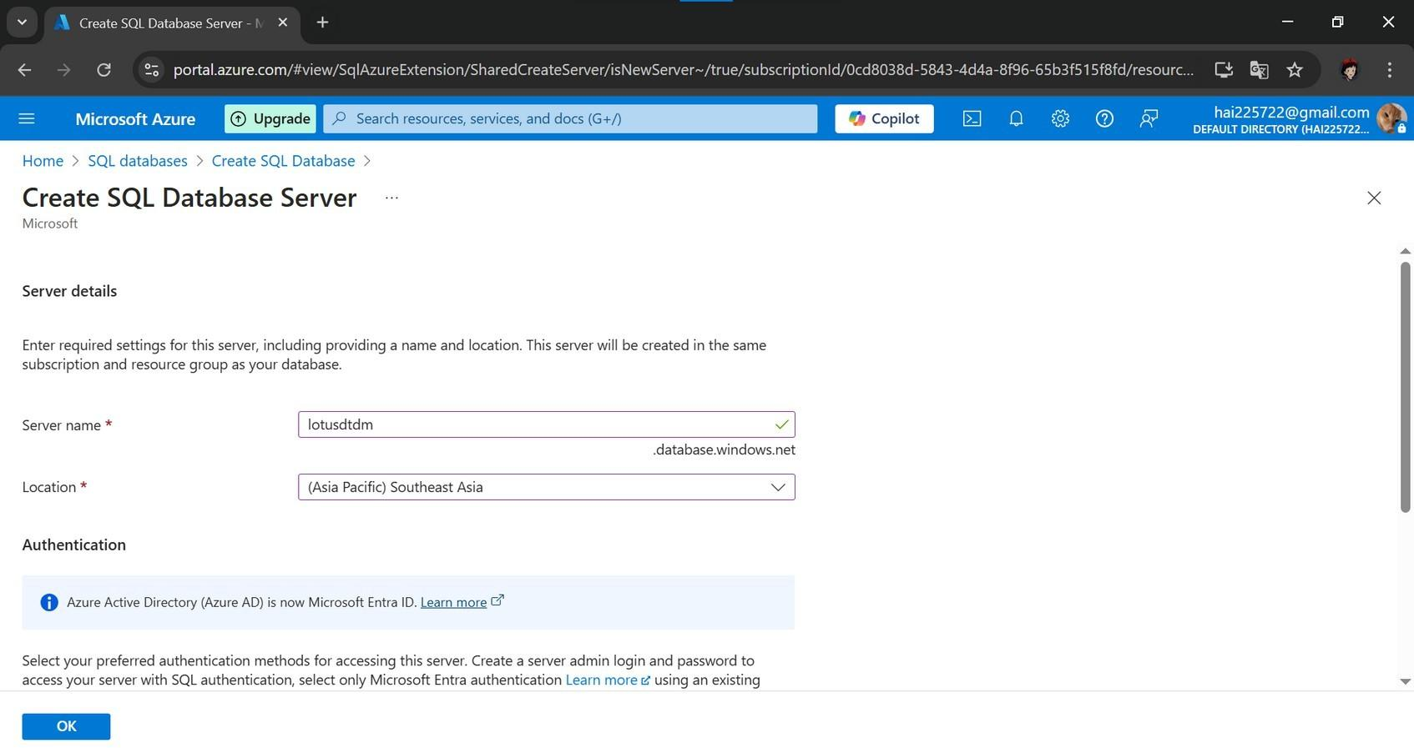
For authentication, we choose Use SQL authentication and set up an admin account and password. Remember this information because we will need it in the next step when connecting to the database. We keep the default configuration for the tags and create the new server.
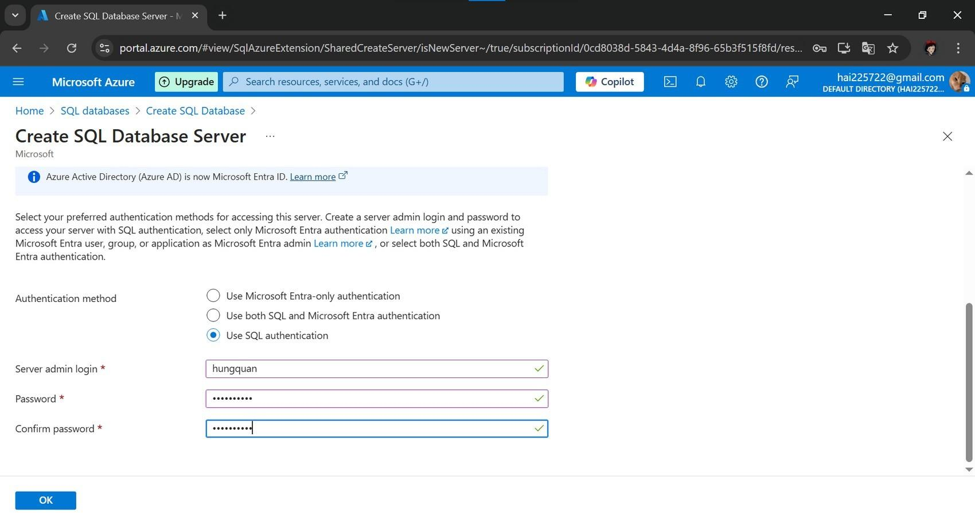

Next, we create an SQL Database. Azure SQL Database is a cloud-based database service that allows us to manage data without maintaining server infrastructure.

We select the RG, name the database, and keep the default configuration. We can see the cost for creating a database. After reviewing the properties, we proceed with the creation.
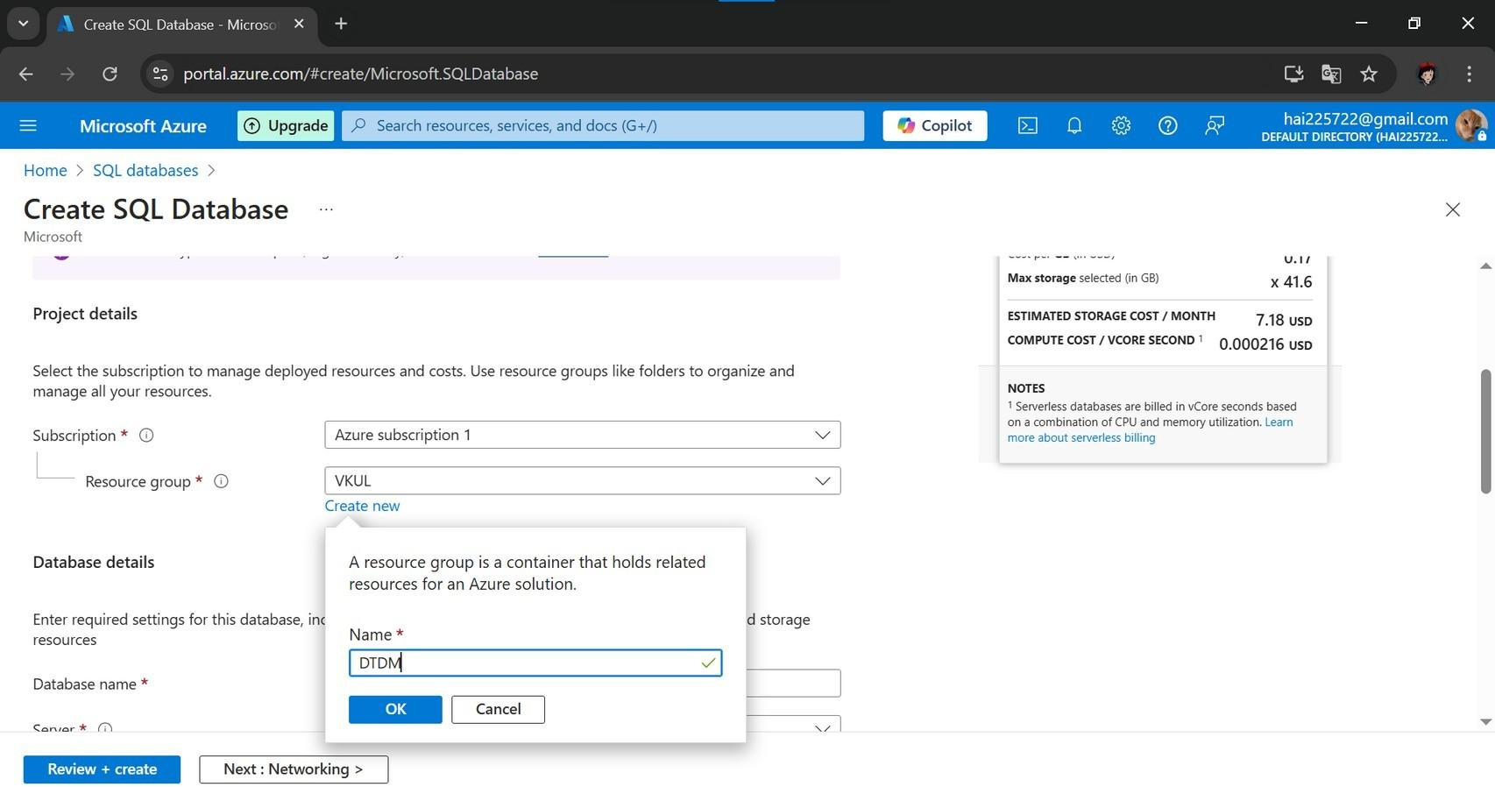
Once the database is created, go to Settings and select Connection strings. This is the connection string that we will use to connect to the SQL Server.
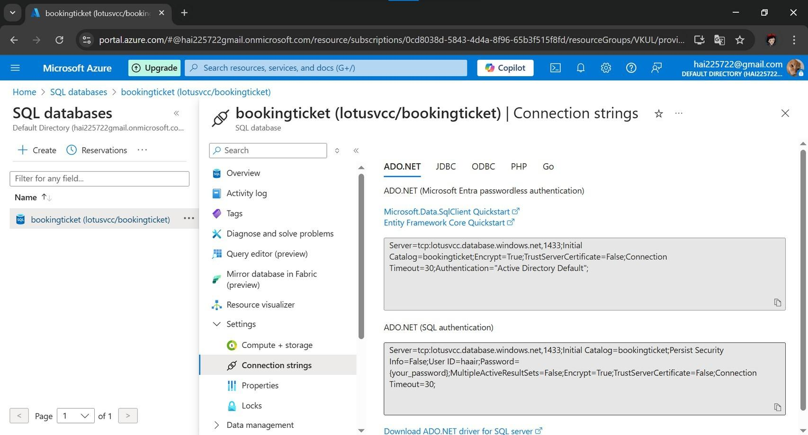
Open SQL Server Management Studio (SSMS) to test the connection. Copy the connection string and paste it here. Remember the admin credentials we set up earlier when creating the SQL Database Server.
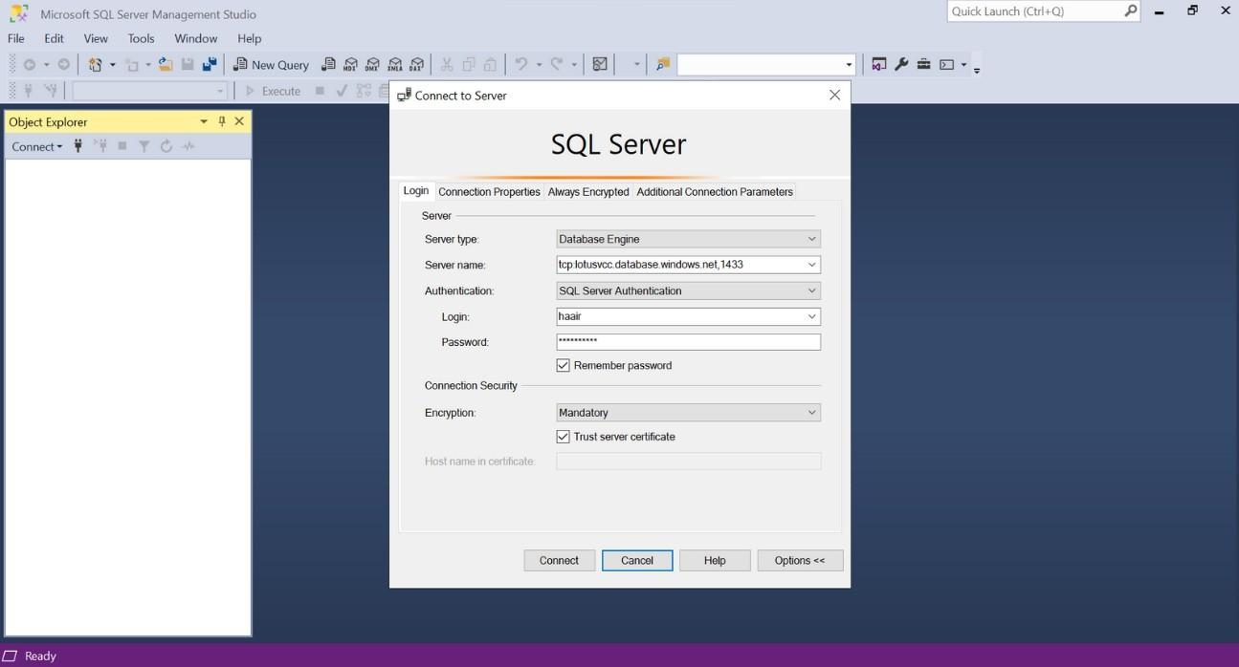
Open the source code, and we need to update the connection string before deploying the application to Azure. In my project, We modify it here.
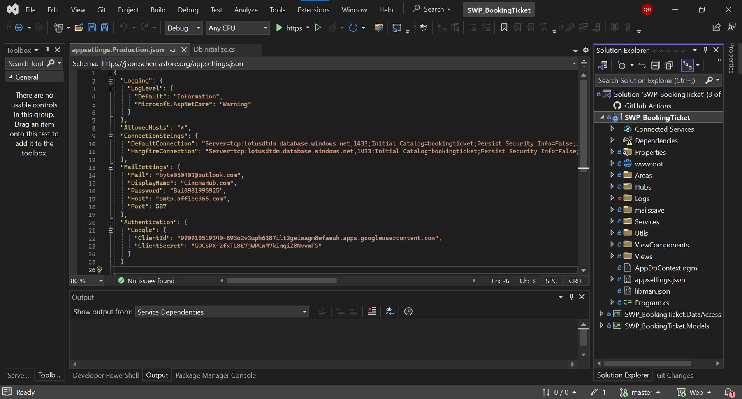

Before the final step, we upload the source code to GitHub. Note that the repository should be set to private.

CI/CD Setup
The last step is to create a Web App. Select App Services, create a new web app, and choose the RG. Name the web app—this will be our domain. Choose a runtime stack and select the version used for application development. Choose the operating system.
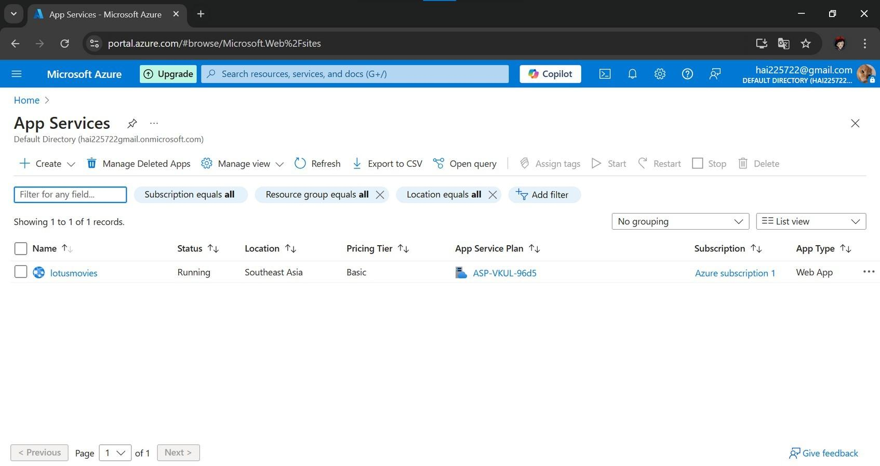
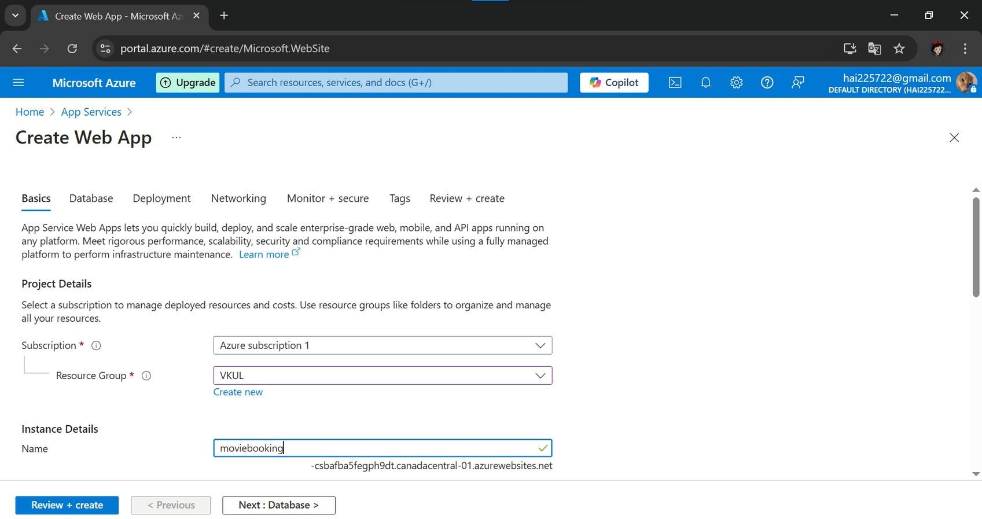
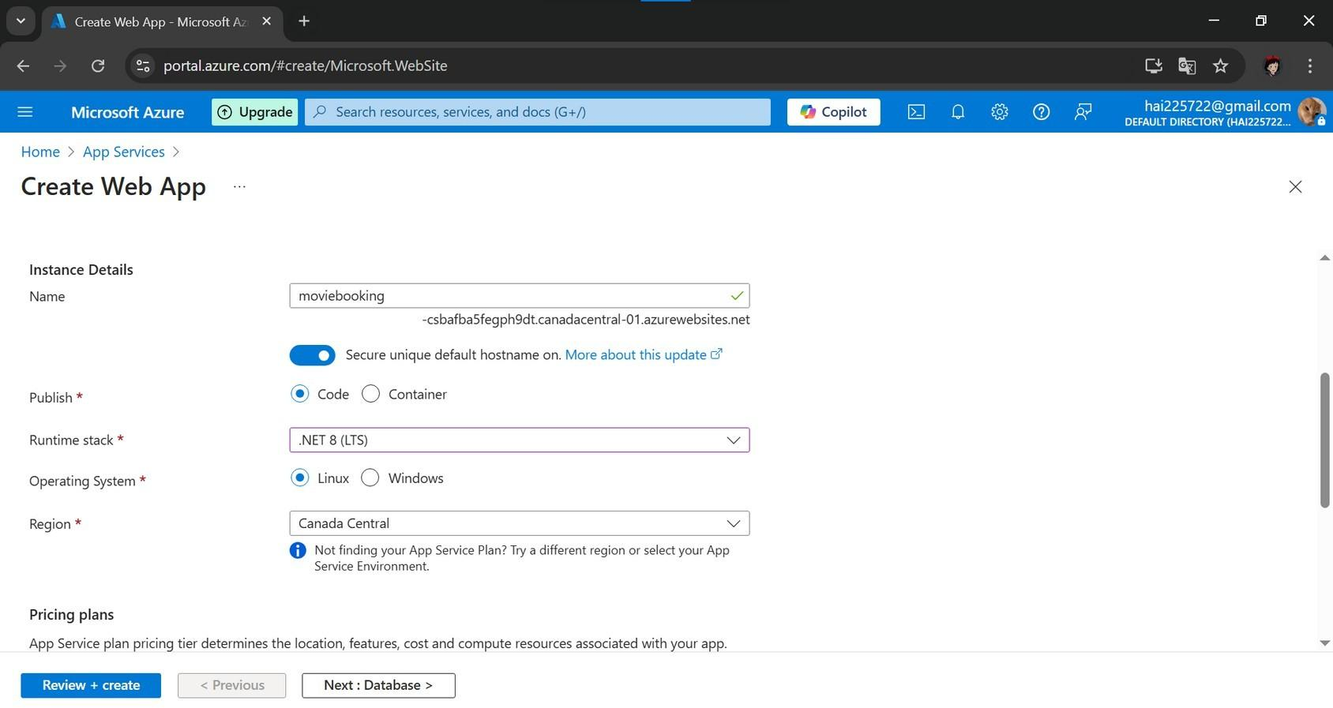
In the Deployment tab, set up CI/CD (Continuous Integration/Continuous Deployment). This makes it easy to deploy code from a GitHub repository using GitHub Actions. Enable continuous deployment, select the GitHub account where the source code was uploaded, and create the pipeline. This process may take some time.
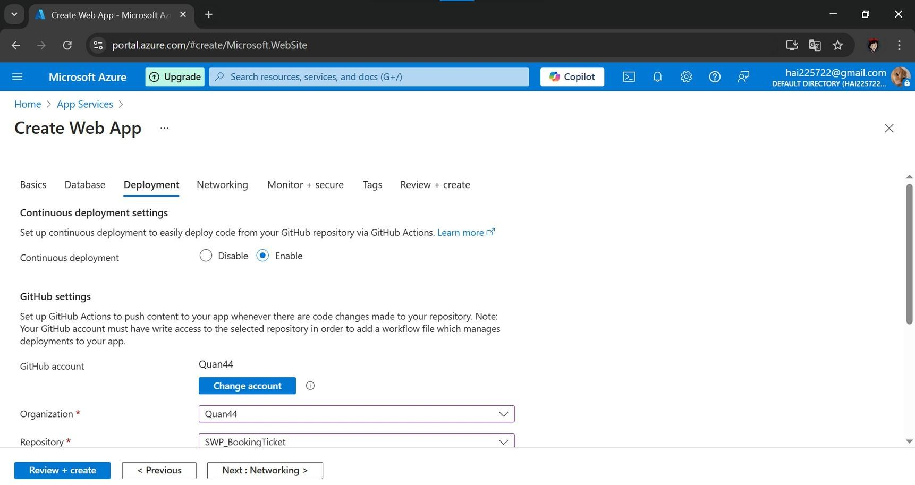
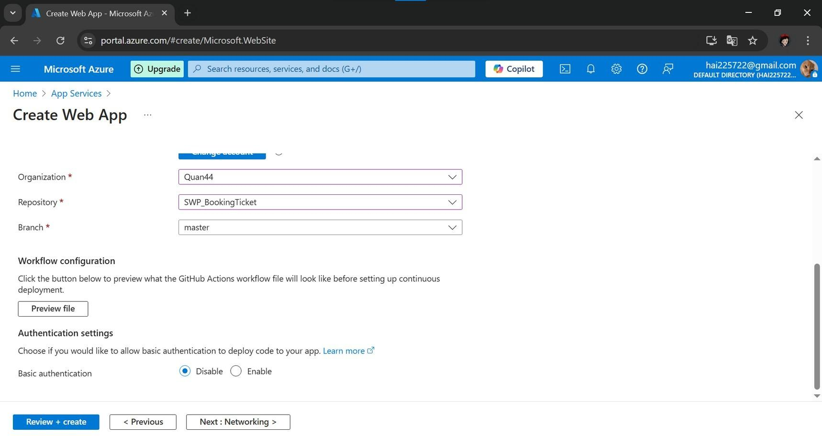
After creation, go to GitHub and check if a CI/CD configuration file has been automatically generated. This setup helps automate the deployment process.

When setting up CI/CD (Continuous Integration/Continuous Deployment) with GitHub Actions, every time you update the source code (push code) to GitHub, the system will automatically build and deploy it to Azure. You no longer need to deploy manually.
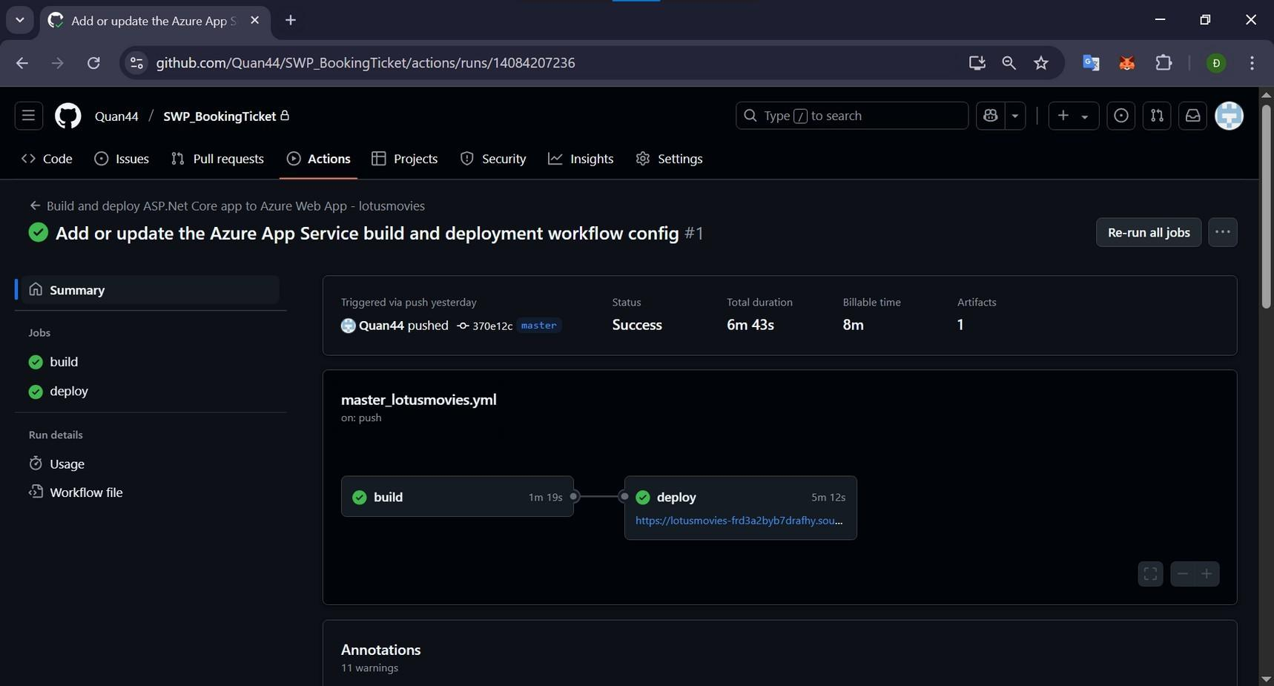
This is file config CI/CD
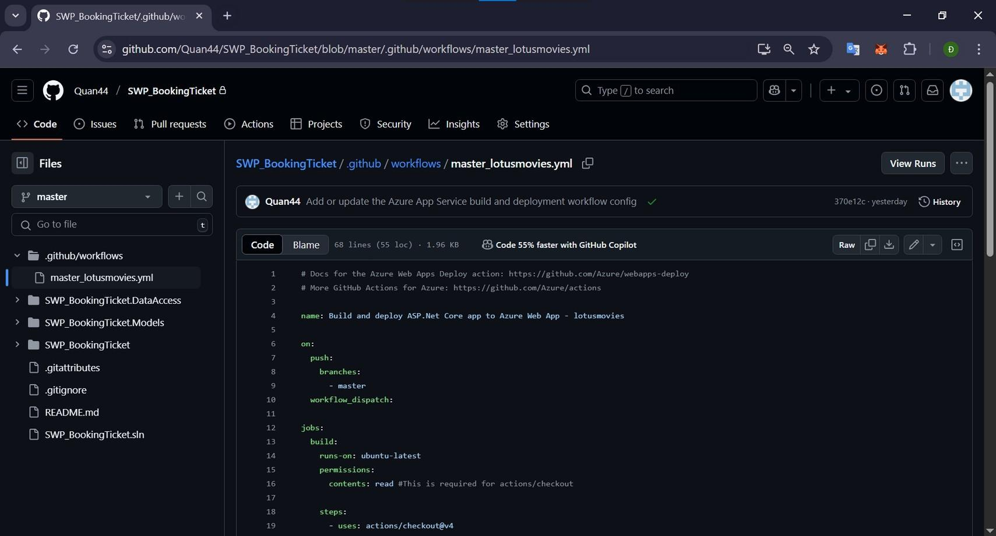
Now, go to the Web App in Azure, open Settings, and select Configuration. Enter this command—this is the default command to run the application. Save the changes, go back to Overview, and Restart the app.
Default command to run application: dotnet SWP_BookingTicket.dll Save and Restart Web App
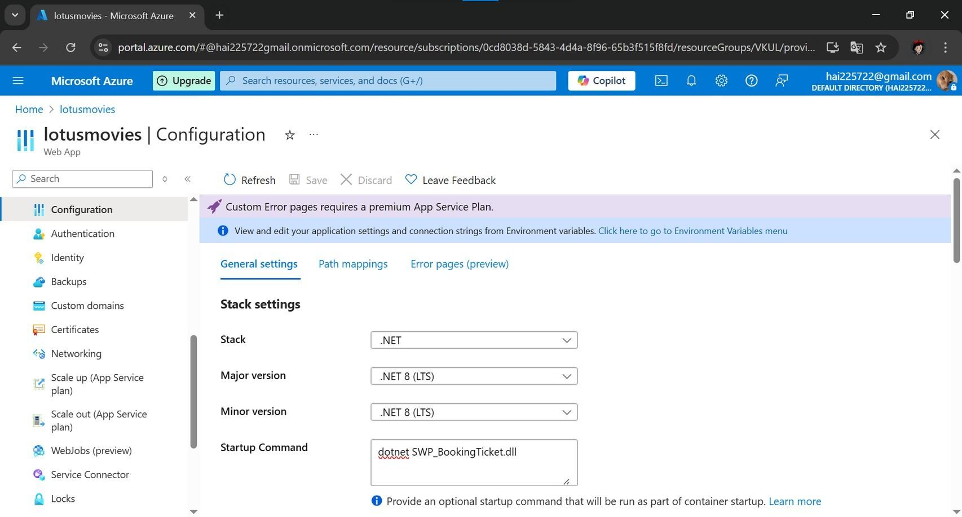
At this point, the website deployment on Microsoft Azure: Cloud Computing Services has been successfully completed.


26

CONCLUSION
Throughout the research and implementation process, this project has provided valuable insights into both theoretical and practical aspects of cloud computing—particularly resource provisioning and virtual server deployment using Microsoft Azure.
By successfully configuring and deploying a web application on a virtual machine, setting up CI/CD pipelines, and enabling shared access for multiple users, we demonstrated a complete lifecycle of cloud-based infrastructure management. The integration of Continuous Integration and Continuous Deployment (CI/CD) greatly improved deployment efficiency and reduced human error, allowing changes to be pushed and tested automatically.
Additionally, this hands-on experience helped reinforce theoretical knowledge of cloud architecture, resource provisioning models (static vs. dynamic), and infrastructure security using Azure features such as Virtual Networks.
In conclusion, this project not only validated the practicality of using Microsoft Azure for shared virtual environments but also highlighted the importance of automation and scalability in modern web application deployment. The successful implementation of CI/CD pipelines, coupled with virtual hosting, represents a strong foundation for future work in DevOps, cloud-native applications, and scalable system architecture.

REFERENCES LIST

- Microsoft Azure Documentation - https://learn.microsoft.com/en-us/azure
- Buyya, R., Vecchiola, C., & Selvi, S. T. (2013). Mastering Cloud Computing: Foundations and Applications Programming. Morgan Kaufmann.
- Mell, P., & Grance, T. (2011). The NIST Definition of Cloud Computing. National Institute of Standards and Technology, U.S. Department of Commerce.
- https://nvlpubs.nist.gov/nistpubs/Legacy/SP/nistspecialpublication800-145.pdf
- Microsoft Learn – Implement CI/CD for Azure Web Apps using GitHub Actions. https://learn.microsoft.com/en-us/azure/developer/github/github-actions
- https://onesme.vn/blog/san-pham/mo-hinh-dich-vu-dien-toan-dam-may.html
- https://www.w3schools.com/

